# Instalar node

* <https://nodejs.org/en/download/(Windows> installer)

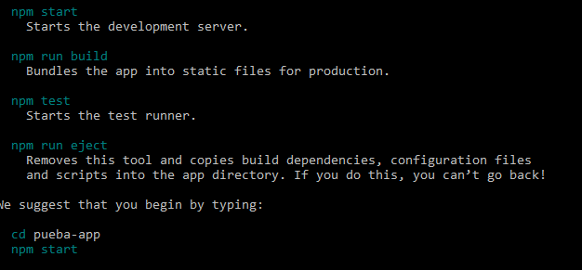

Tutto - ejemplo

<https://miguelgomez.io/react/tutorial-react-js-introduccion/>

<https://ed.team/blog/5-cosas-que-te-ayudaran-con-reactjs>